**Business Modelling**

A commission-based business model for a restaurant recommender system can be an effective way to generate revenue. Here's how it could work:

1. **Partner with Restaurants**: Establish partnerships with restaurants and food establishments that are interested in attracting new customers. Negotiate commission rates for each successful referral or transaction made through the recommendation system.
2. **User Referrals:** Encourage users to discover and try out recommended restaurants through the platform. When a user makes a reservation or places an order at a partner restaurant based on the system's recommendation, the system earns a commission from the restaurant.
3. **Tracking and Attribution:** Implement a tracking system to monitor and attribute referrals accurately. This can be achieved through unique referral codes, tracking links, or customized landing pages that identify the source of the referral. This ensures that the system receives proper credit for generating the customer.
4. **Transparent Commission Structure:** Clearly define the commission structure for partner restaurants. It can be a percentage of the total bill amount or a fixed amount per transaction. Ensure that the terms and conditions regarding commission payments are transparent and communicated to the partners upfront.
5. **Payment Processing:** Set up a streamlined payment processing system to handle commission payments. Regularly reconcile referral data with the partner restaurants and initiate timely commission pay-outs based on the agreed-upon terms.
6. **Continuous Relationship Building:** Maintain strong relationships with partner restaurants. Provide them with regular reports on referral performance, customer feedback, and other relevant data to demonstrate the value generated by the recommendation system. This can help build trust and foster long-term partnerships.
7. **Expansion and Scalability:** As the recommendation system gains traction and more restaurants partner with the platform, consider expanding to new geographical areas or offering additional services like food delivery. Scaling the business can lead to increased revenue opportunities and a wider customer base.
8. **Quality Control and User Experience:** It's crucial to maintain the integrity of the recommendation system by ensuring the restaurants recommended are of high quality and meet user expectations. Regularly monitor user feedback, ratings, and reviews to ensure customer satisfaction and avoid negative experiences that could harm the reputation of the platform remember to adapt and iterate your business model based on the market dynamics, customer preferences, and the specific needs of your restaurant partners. Regularly assess the effectiveness of the commission-based model and make adjustments as necessary to optimize revenue generation and sustain the recommender system's growth.

It is essential to be flexible and responsive to market dynamics, customer preferences, and the unique requirements of restaurant partners. Continuously evaluate the performance of your commission-based business model and make necessary modifications to enhance revenue generation and ensure the ongoing growth of your restaurant recommender system.

**PRODUCT DESCRIPTION**

The restaurant recommendation website is designed to connect users with the perfect dining experiences while generating revenue through successful referrals. With a user-friendly interface, we help individuals discover and explore a wide range of restaurants based on their preferences, location, and culinary interests.

Through strategic partnerships with restaurants, we offer a curated selection of establishments that have agreed to collaborate with our platform. As users browse through our recommendations, make reservations, or place orders at partner restaurants, we earn a commission for each successful transaction.

**Working model Flowchart**

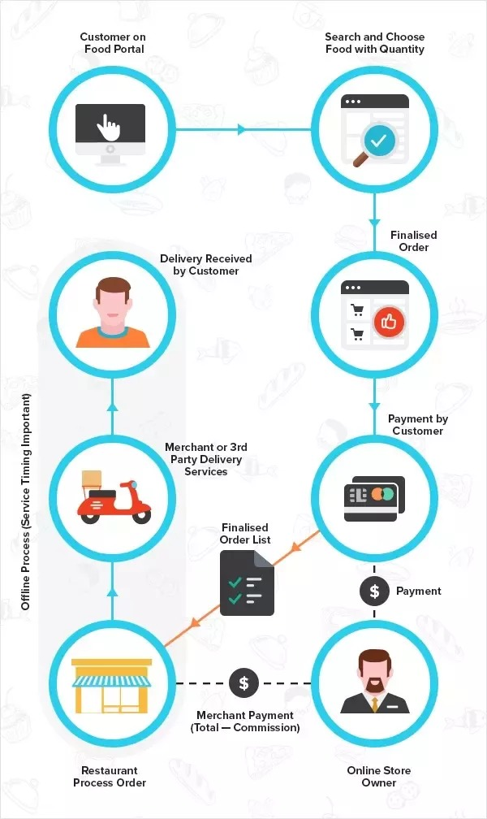

**MARKET ANALYSIS**

The market for restaurant recommender systems has experienced significant growth in recent years. As consumers increasingly rely on online platforms and mobile apps to make dining decisions, the demand for personalized restaurant recommendations has surged.

Key factors driving the market include the widespread use of smartphones and internet platforms, the need for personalized recommendations, and the competitive landscape. Emerging technologies like AI and ML are enhancing the accuracy and relevance of recommendations. It is essential to consider regional differences, regulatory compliance, and staying ahead of technological advancements to succeed in this market. Overall, the restaurant recommender system market offers significant growth potential by catering to consumers' preferences and helping restaurants attract new customers.

**OPERATING PLAN**

1. Develop an intuitive platform for users to access restaurant recommendations, menus, reviews, and reservations.
2. Collect and analyse user data to generate personalized recommendations.
3. Establish partnerships with a variety of restaurants, negotiating commission rates or revenue-sharing agreements.
4. Streamline the onboarding process for partner restaurants and provide training and support.
5. Implementing marketing strategies to attract and engage users, utilizing digital channels and user reviews.
6. Ensure recommended restaurants meet high-quality standards through regular monitoring and user feedback.
7. Provide responsive customer support channels for user queries and technical issues.
8. Generate revenue through commission-based models, referral tracking, and exploring additional revenue streams.
9. Continuously update and optimize the system based on user feedback and emerging technologies.
10. Conduct regular market analysis to identify market opportunities.

**MARKETING PLAN**

1. Identify the target audience and their preference such as food enthusiasts, travellers, or locals seeking recommendations.
2. Clearly communicate the unique benefits of the recommender system.
3. Establish an intuitive website with a compelling design and intuitive user experience.
4. Create engaging content about dining experiences, food trends, and partner restaurant features.
5. Leverage social media for community engagement and influencer collaborations.
6. Seek partnerships with local businesses and travel agencies for cross-promotion.